Name:- Shreyash Patil

PRN:- 22510039

Batch: T3

ADS assignment 11

NEO4j resarch paper Graph:

Frontend:-

Check citation path checks if the Paper A has citied Paper B

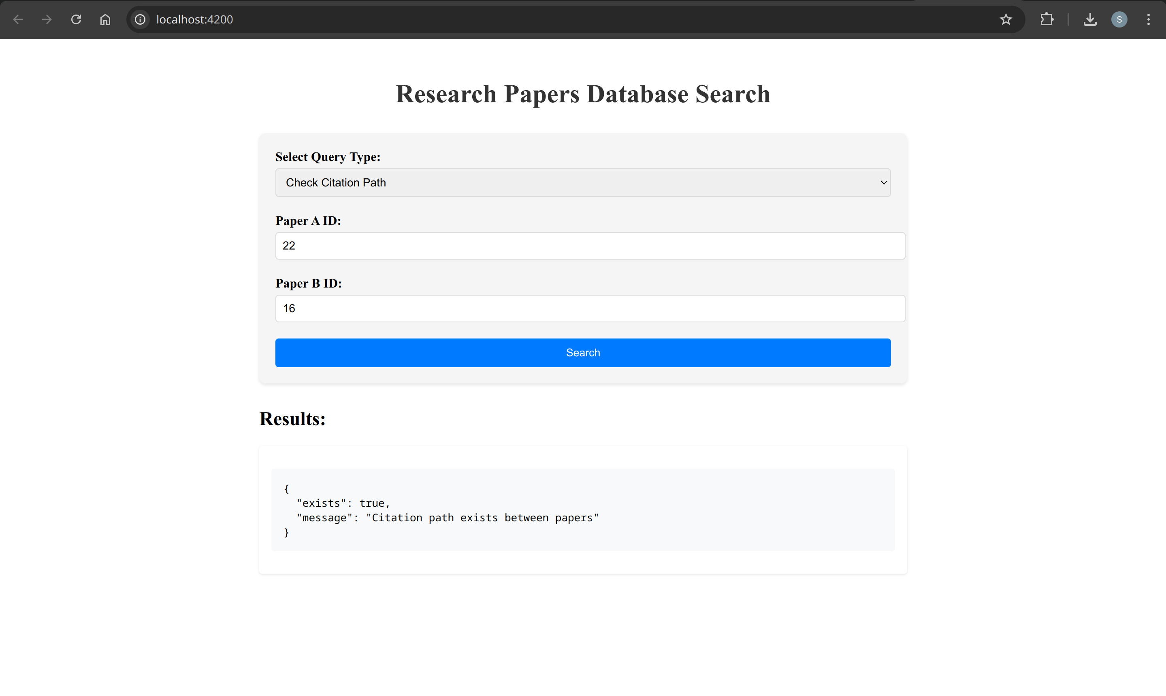

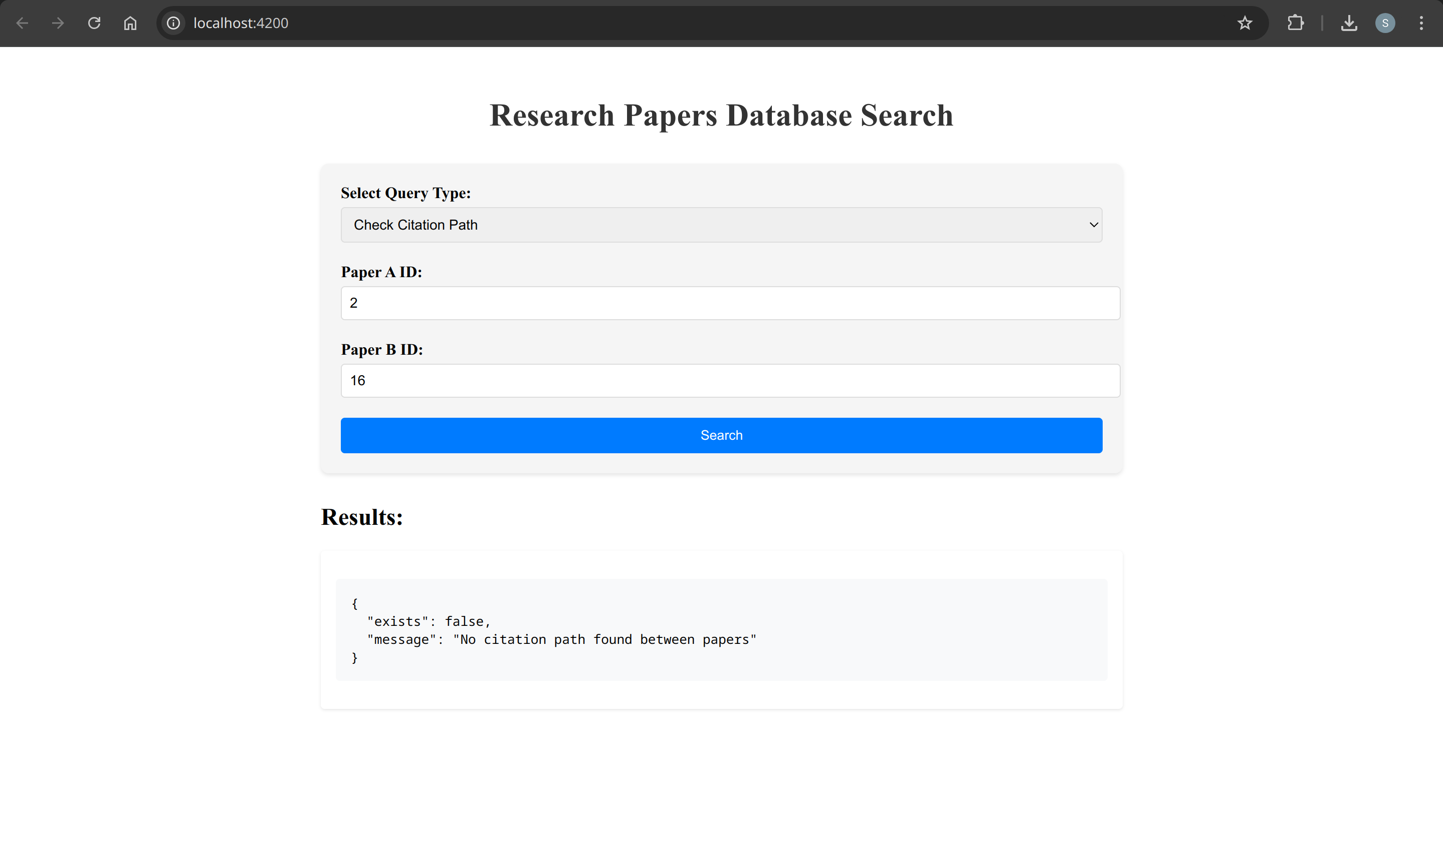

It also gives Under what topic the paper is classified:

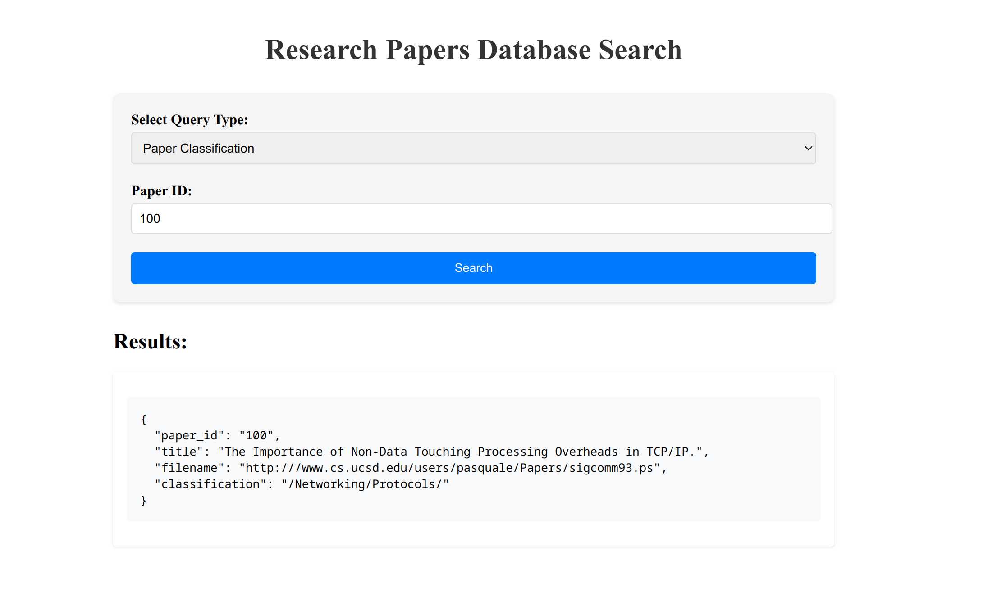

Under Paper details:

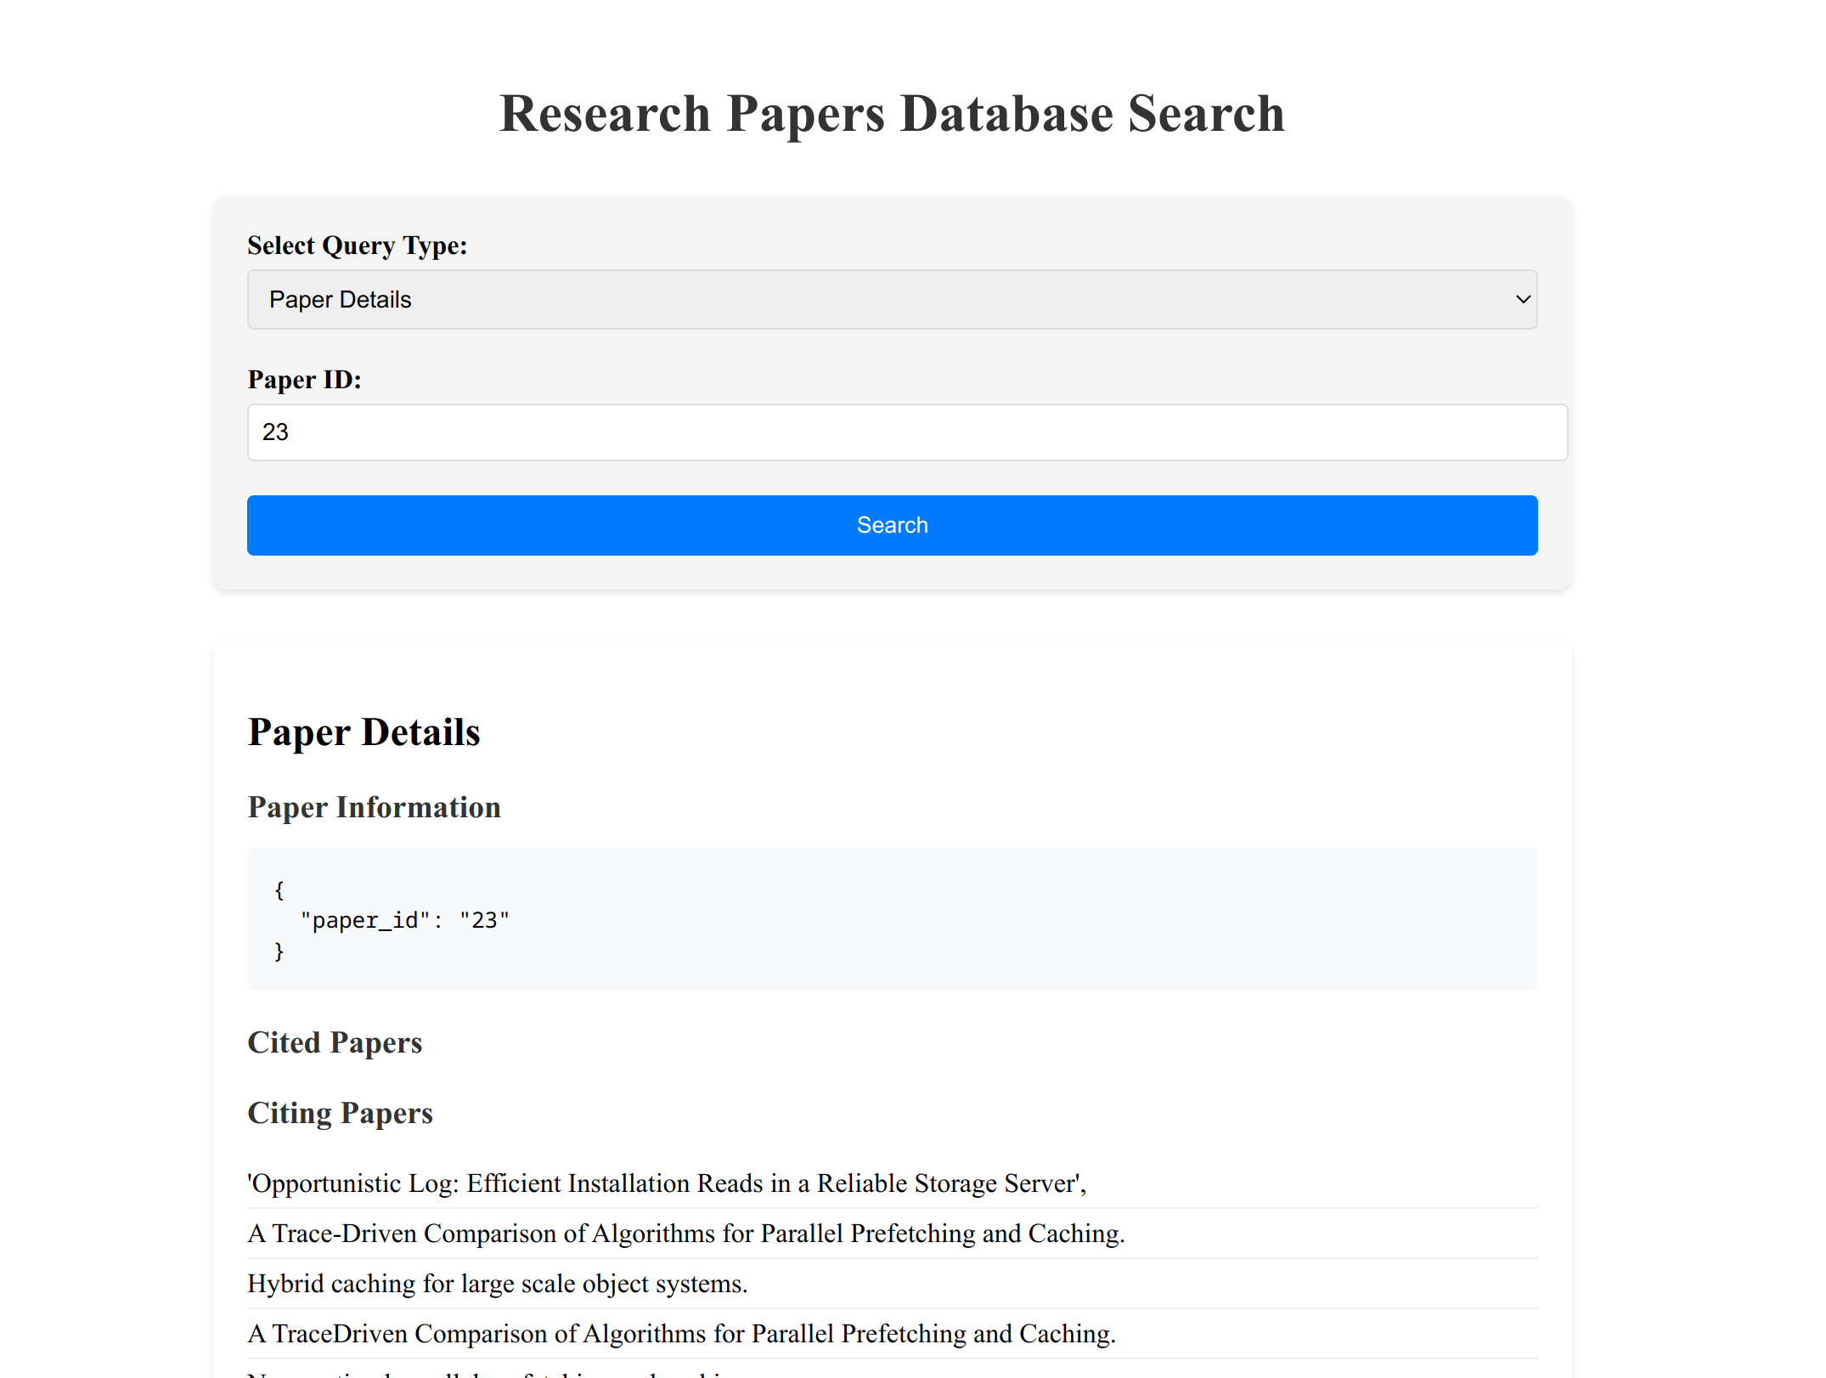  
And view all papers:

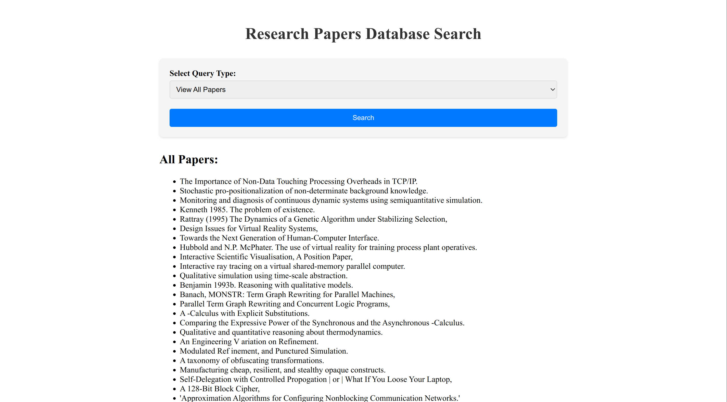

The data was loaded through CSV in neo4j  
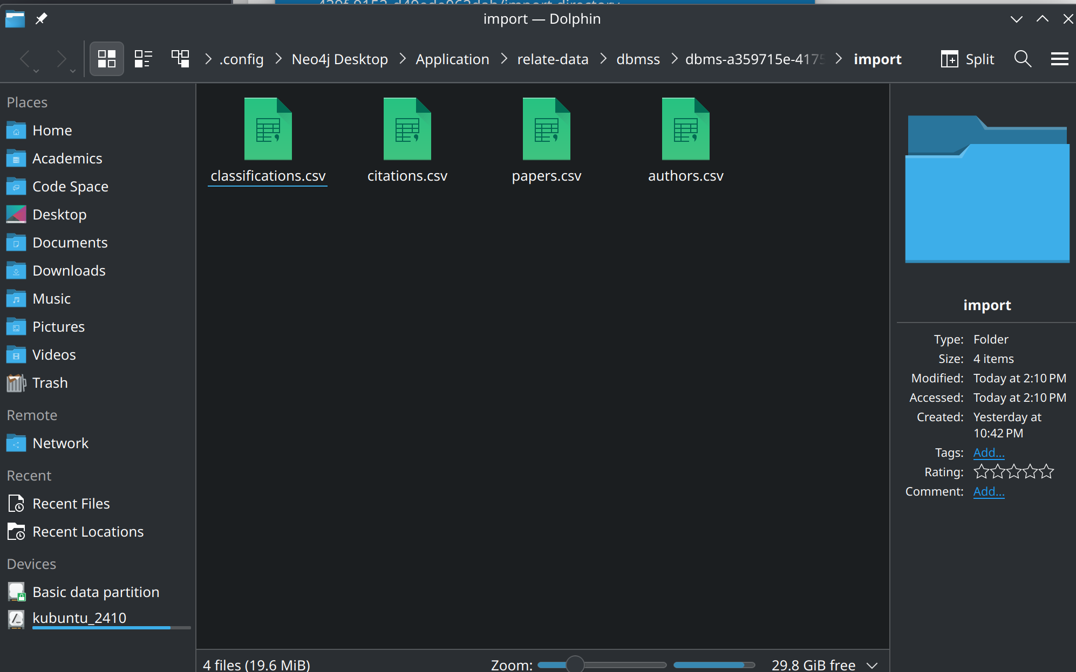

Running import commands:

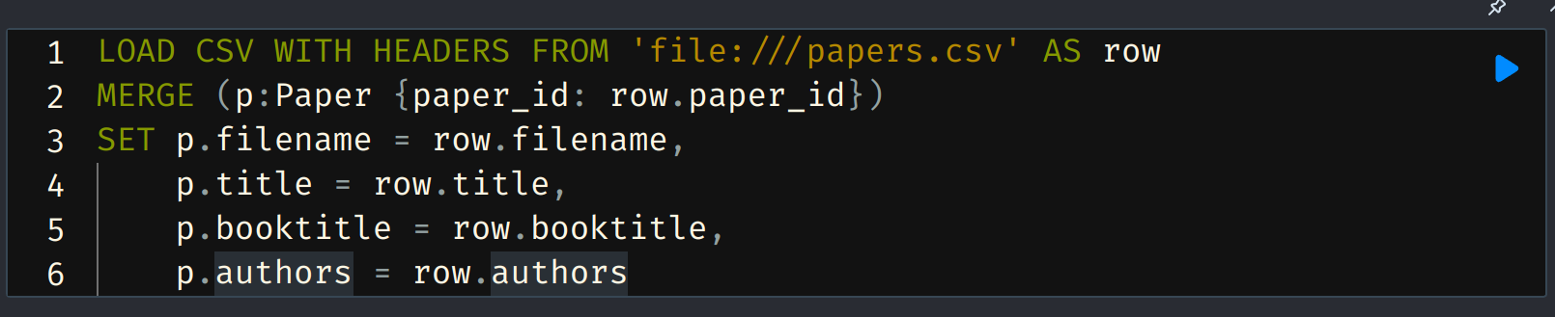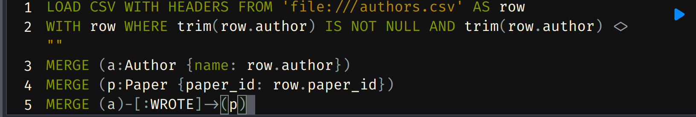  
For each CSV:

Running commands to show citing for paper 2  
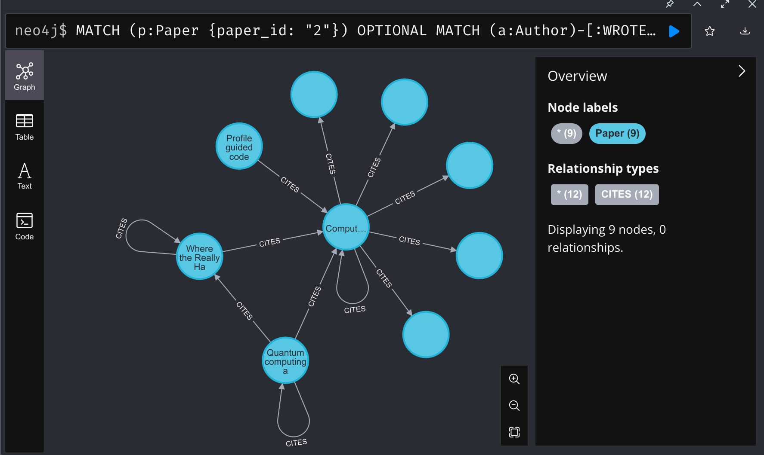  
Running command to show 50 papers

